MT 160.1 SPONTANEITY OF DISPERSION OF LIQUID FORMULATIONS FORMING SUSPENSIONS ON DILUTION WITH WATER

SCOPE
This method is intended to determine the spontaneity of dispersion, which is defined as the percentage of one or more active ingredient(s) forming a suspension after limited agitation and remaining in suspension over a short period of time. The method is applicable to liquid formulations forming suspensions on dilution with water.

REASONS FOR THE REVISION
The method has been brought in line with MT 184.1 regarding general procedures, reagents and equipment. A temperature requirement of 25 ± 5 °C has been set. The solvent extraction procedure has been removed.
Where same conditions are used, results obtained with MT 160.1 are equivalent to those obtained with MT 160.
MT 160.1 supersedes MT 160.

OUTLINE OF METHOD
The method involves preparing a suspension of the formulation in Standard Water. After standing under defined conditions the top 9/10ths are drawn off, and the remaining 1/10th is assayed. The spontaneity of dispersion is calculated as the percentage of sample remaining suspended.
To reflect the ease of forming a dispersion and differently to the determination of suspensibility (MT 184.1), MT 160.1 applies only one inversion to form the dispersion and reduces the standing time to 5 min.

REAGENTS

CIPAC Standard Water D, MT 18.1.4, unless otherwise specified
Water, deionised

APPARATUS
Analytical balance, with an accuracy of at least ± 0.001 g

Beakers of suitable sizes

Drying dish, e.g. glass, for drying of residues
Measuring cylinders 250 ml with stopper, the distance between the graduations 0 ml and 250 ml should be between 20 cm and 26 cm, and between the 250 ml mark and the bottom of the stopper 3 cm to 7 cm (see Fig. 1)

Stopwatch
Suction tube or alternatively a U-shaped tube, both connected to a reservoir and a suitable source of vacuum (see Fig. 1 and Fig. 2).
Water bath or drying device capable of maintaining a temperature of 70 °C

PROCEDURE

All operations are performed at ambient temperature (25 ± 5 °C).

(a) Preparation of the suspension
Fill the measuring cylinder with 237.5 ml Standard Water. Carefully add 12.5 ml of test sample from a height of approximately 1 cm above the top of the cylinder onto the surface of the water. The test sample may either be added volumetrically or gravimetrically after determination of its density. Complete the addition within approximately 15 s. Immediately afterwards, insert the stopper and invert the cylinder once (Note 1).

(b) Determination of sedimentation
Place the cylinder on a flat surface in an upright position free from vibration and protected from direct sunlight. Let it stand for 5 min. Then remove the stopper and withdraw the top 225 ml (= top 9/10ths) using the suction tube. Take care that the tip of the tube is always only a few mm below the falling level of the liquid except in the latter stages when the liquid must not be withdrawn from below the 25 ml mark.

(c) Assay of the remaining 25 ml
The remaining 25 ml in the cylinder must be assayed in one of the following ways (Note 2):
(c1) chemically, by an appropriate analytical method for the active ingredient(s)
(c2) gravimetrically, by transferring the remaining 25 ml of the suspension quantitatively into a drying dish, rinsing the cylinder with deionised water, evaporating the water and drying the residue in the drying dish to a constant weight. For drying a temperature of approx. 70 °C is recommended. If the active ingredients (or formulation components) are not stable at this temperature, an appropriate lower drying temperature has to be used. When using this assay, the dry weight ratio of the test sample needs to be determined in addition (Note 3).
The same temperature and conditions should be applied for drying the remaining 25 ml in the cylinder and the liquid formulation.

CALCULATION

Each of the assay methods yields a mass:
- the chemical assay gives the mass of each active ingredient,
- the gravimetric assay yields the combined mass of non-volatile solids.
Using the mass obtained, calculate the suspensibility using the following equation.
Spontaneity of dispersion [%] | 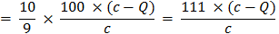 | where:

(a) Chemical assay method:
(a1) if the sample is added gravimetrically:
c = a x b / 100; total mass of active ingredient in the cylinder [g]
a = content of the active ingredient (w/w) in the formulation [%]
b = mass of sample added to the cylinder [g]
Q = mass of the active ingredient in the 25 ml remaining in the cylinder [g]
(a2) if the sample is added volumetrically:
c = a x b; total mass of active ingredient in the cylinder [g]
a = content of the active ingredient (w/v) in the formulation [g/ml]
b = volume of sample added to the cylinder [ml]
Q = mass of the active ingredient in the 25 ml remaining in the cylinder [g]

Calculate the spontaneity of dispersion for each active ingredient individually.

(b) Gravimetric assay method:
(b1) if the sample is added gravimetrically:
c = a x b; dry weight of the sample in the cylinder [g]
a = dry weight ratio of the sample: see Note 3
b = mass of sample added to the cylinder [g]
Q = mass of dry residue in the 25 ml remaining in the cylinder [g]
(b2) if the sample is added volumetrically:
c = a x b; dry weight of the sample in the cylinder [g]
a = dry weight ratio of the sample: see Note 3
b = V x d where:
V = volume of sample added to cylinder [ml]
d = density of the sample [g/ml]
Q = mass of dry residue in the 25 ml remaining in the cylinder [g]

REPORTING
Report the spontaneity of dispersion to the nearest 1% together with the following parameters:
- Standard Water used, if not Standard Water D
- assay method used

Note 1 The expression "invert the cylinder" implies that the cylinder is turned by hand by 180 degrees and is brought back to its original position, the whole operation being completed in approximately 2 s.
Note 2 Chemical assay is a reliable method to measure the mass of active ingredients in suspension. However, simpler methods such as gravimetric determination may be used on a routine basis, provided that these methods have been shown to give results that are in agreement to those of the chemical assay method. This is equally true for formulations containing one or more active ingredients.
Note 3 Liquid formulations contain volatile (e.g. water) and non-volatile components. The ratio between the two must be determined experimentally. Either dry an aliquot of the test sample directly or dilute the test sample in a small portion of deionized water (approx. 10 to 30 ml) before drying to avoid film or skin formation. Evaporate to dryness on a water bath or in a drying oven. The same temperature and conditions as used for drying the remaining 25 ml in the cylinder need to be applied. Record the weight of the residue to the nearest mg. Calculate the dry weight ratio by the following equation:
Dry Weight Ratio =

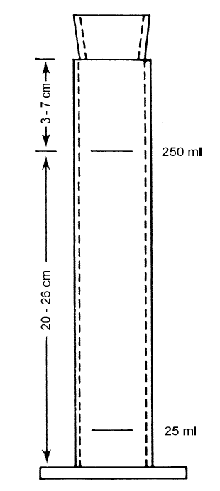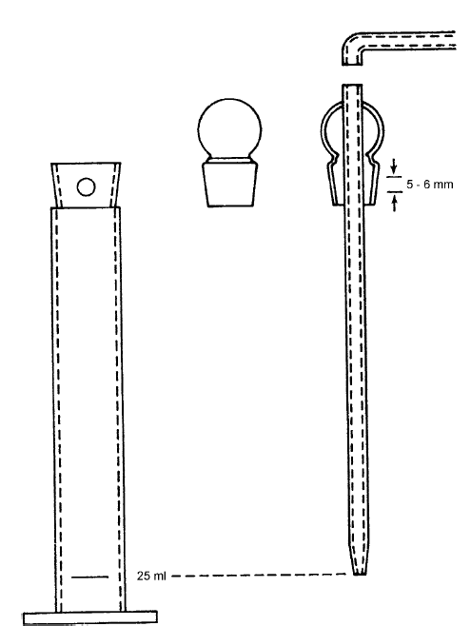

Fig. 1: A 250 ml measuring cylinder for determination of spontaneity of dispersion, with a special fitting for the removal of the top 9/10ths of the suspension. Left, mesuring cylinder with opening. Centre, plain stopper. Right, glass suction tube equipped with special stopper. The length of the tube must be such that when inserted in the cylinder the tip is exactly at the 25 ml graduation. The special stopper has a hole of 5 to 6 mm diameter, which should coincide with the hole in the cylinder neck when the suction tube is in position.
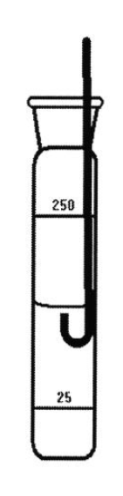
Fig. 2: U-shaped metal tube with an internal diameter of about 2-3 mm that can be used as alternative to the glass suction tube of Fig. 1. The length of the tube must be such that when the tube reaches the bottom of the cylinder exactly 25 ml of suspension remain in the cylinder.

